**Medical Care Collection Fund (MCCF)**

Electronic Data Interchange (EDI) Transaction Application Suite (TAS)

User Guide



**November 2018**

Department of Veterans Affairs

Office of Information and Technology (OI&T)

Revision History

NOTE: The revision history cycle begins once changes or enhancements are requested after the document has been baselined.

| Date | Revision | Description | Author |
| --- | --- | --- | --- |
| 11/19/2018 | 1.3 | Update to Login/Logout and UI Screens | Kim Battles |
| 6/4/2018 | 1.2 | Final Version Submitted for Approval | Kim Battles |
| 5/29/2018 | 1.1 | Final Draft | Kim Battles |
| 9/16/2017 | 1.0 | Initial Draft | Kim Battles |

.

**Artifact Rationale**

Per the Veteran-focused Integrated Process (VIP) Guide, the User Guide is required to be completed prior to Critical Decision Point #2 (CD2), with the expectation that it will be updated as needed. A User Guide is a technical communication document intended to give assistance to people using a particular system, such as VistA end users. It is usually written by a technical writer, although it can also be written by programmers, product or project managers, or other technical staff. Most user guides contain both a written guide and the associated images. In the case of computer applications, it is usual to include screenshots of the human-machine interfaces, and hardware manuals often include clear, simplified diagrams. The language used is matched to the intended audience, with jargon kept to a minimum or explained thoroughly. The User Guide is a mandatory, build-level document, and should be updated to reflect the contents of the most recently deployed build. The sections documented herein are required if applicable to your product.

**Table of Contents**

1. Introduction 1

1.1. Purpose 1

1.2. Document Orientation 1

1.2.1. Organization of the Manual 1

1.2.2. Assumptions 2

1.2.3. Coordination 2

1.2.4. Disclaimers 2

1.2.4.1. Software Disclaimer 2

1.2.4.2. Documentation Disclaimer 2

1.2.5. Documentation Conventions 2

1.2.6. References and Resources 3

1.3. Enterprise Service Desk and Organizational Contacts 3

2. Portal Summary 1

2.1. System Requirements 1

2.2. Portal Configuration 1

2.3. Data Flows 1

2.4. User Access Levels - Profiles 2

2.5. Continuity of Operation 3

3. Getting Started 3

3.1. Future Release - Logging On 3

3.2. Future Release - Logging Out of the Current MCCF EDI TAS Portal Session 5

3.3. Elements and Functionality of the MCCF EDI TAS Portal 1

3.3.1. MCCF EDI TAS Portal Home Page 1

3.3.2. Portal Menu 2

3.3.3. Accessing Product Pages 4

3.3.4. Sitewide Search 8

3.3.5. Accessing FAQs 9

3.3.6. Accessing Contact Us Page 11

3.3.7. Accessing Help 12

3.3.8. Accessing the eRevenue Resources SharePoint Site 14

3.3.9. Accessing the ICBWeb 16

3.4. Caveats and Exceptions 17

4. Using the Software 17

4.1. Special Instructions for Error Correction 17

5. Acronyms and Abbreviations 17

6. Appendix 19

*This page is left blank intentionally*

# Introduction

The Medical Care Collection Fund (MCCF) Electronic Data Integration (EDI) Transaction Application Suite (TAS) Portal, referred hereafter as the MCCF EDI TAS Portal, is a web-based application that was designed to support business processes with electronic data mandates and infrastructure; establish common/accessible documentation; create more robust billing capabilities; address industry-wide goals for architecture; performance and connectivity; improve response times, security and acknowledgements; and enhance error reporting and patient identification.

## Purpose

The purpose of the MCCF EDI TAS Portal User Guide is to provide users with essential information to ensure full use of the MCCF EDI TAS Portal. This manual includes a description of the system functions and capabilities and step by step actions for system access and use. This document was written based on the MCCF EDI TAS Core technical reference standards documented in the MCCF EDI TAS Portal System Design Document (SDD).

This MCCF EDI TAS Portal User Guide will be a living document and edits will be made on a regular basis. Please, always refer to the online version of this guide on the MCCF EDI TAS SharePoint site in order to have the most updated version of this guide.

## Document Orientation

### Organization of the Manual

The following is a brief descriptive outline of the major sections within this guide. Please click on the hyperlink to navigate directly to that section.

1. Introduction: describes the purpose of this user guide, document orientation (i.e. assumptions, coordination, disclaimers, document conventions, references and resources) and Enterprise Service Desk (ESD) contacts.
2. System Summary: provides details on the system configuration; data flows; user access levels; and continuity of operations.
3. Getting Started: describes how the user accesses the portal, the default view, how to exit the system, any caveats and exceptions, general patching, and how to report technical or content issues.
4. Using the Software: offers step-by-step instructions for using the features of the MCCF EDI TAS Portal.
5. Troubleshooting: provides special instructions for error correction, how to report technical or content issues, how to provide user feedback, and how to contact eBusiness for immediate assistance.
6. Acronyms and Abbreviation: a brief list of acronyms and abbreviations included in this guide.
7. Appendix:

### Assumptions

This User Guide is written from the perspective of the end user, assuming the following:

* User has basic knowledge of the underlying requirements for release of this project
* User understands the impact the release may have on other systems (e.g. dependencies, coordinating release during schedule maintenance to avoid service interruptions, resource constraints)
* User has an active Department of Veterans Affairs (VA) network account
* User can open, navigate, and use a web browser
* User can use web-based applications, their menu options, and navigation tools
* User has been provided with the Uniform Resource Locator (URL) for the MCCF EDI TAS Portal Login Page
* User has been provided with appropriate access to the MCCF EDI TAS Portal (e.g. read-only or administrative rights) and can access the portal directly from the network on their Government Furnished Equipment (GFE) or via Citrix Access Gateway (CAG)

### Coordination

Content under development

### Disclaimers

#### Software Disclaimer

*This software was developed at the Department of Veterans Affairs (VA) by employees of the Federal Government in the course of their official duties. Pursuant to title 17 Section 105 of the United States Code this software is not subject to copyright protection and is in the public domain. VA assumes no responsibility whatsoever for its use by other parties, and makes no guarantees, expressed or implied, about its quality, reliability, or any other characteristic. We would appreciate acknowledgement if the software is used. This software can be redistributed and/or modified freely if any derivative works bear some notice that they are derived from it, and any modified versions bear some notice that they have been modified.*

#### Documentation Disclaimer

*The appearance of external hyperlink references in this manual does not constitute endorsement by the Department of Veterans Affairs (VA) of this Website or the information, products, or services contained therein. The VA does not exercise any editorial control over the information you may find at these locations. Such links are provided and are consistent with the stated purpose of the VA.*

### Documentation Conventions

This manual uses several methods to highlight different aspects of the material.

* Descriptive text is presented in a proportional font (as represented by this font). A proportional font is a font type in which the width of letters and symbols varies depending on the letter or symbol.
* Images of computer online displays (i.e. character-based screen captures/dialogs) are shown in a non-proportional font and enclosed within a box. Also included are Graphical User Interface (GUI) Microsoft Windows images. A non-proportional font is a font whose letters and characters each occupy the same amount of horizontal space.
* The user guide was developed using the most recent template provided by the VA VIP SharePoint site, and uses pre-defined styles for all formatting (e.g. paragraph text, bullets, enumeration).
* Notes are used to call the user’s attention to additional information relevant to the action described in that section, but that is not part of the step-by-step instructions.

| **Symbol** | **Description** |
| --- | --- |
| Symbol for additional information (letter "i") inside a circle. | NOTE: Used to inform the reader of general information including references to additional reading material |
| Triangle with an exclamation point (!) inside to indicate caution for the reader to take special notice of critical information. | **CAUTION: Used to caution the reader to take special notice of critical information** |

### References and Resources

MCCF EDI TAS Portal related documentation can be accessed from the MCCF EDI TAS SharePoint Site:

* [MCCF EDI TAS System Style Guide](https://vaww.vashare.oit.va.gov/sites/mccf/TASCore/MCCF_EDI_TAS_System_Design_Document_v0.7.pdf)
* [TAS Core US1406-US1409 SDD](https://vaww.vashare.oit.va.gov/sites/mccf/TASCore/TAS%20TASCore%20US1406-US1409%20SDD.docx)

## Enterprise Service Desk and Organizational Contacts

Table 1 lists organizational contacts needed by site users for troubleshooting purposes. Support contacts are listed by name of service responsible to fix the problem, description of the incident escalation, associated tier level and contact information (email and phone number).

|  |  |  |  |
| --- | --- | --- | --- |
| **Name** | **Role** | **Org** | **Contact Info** |
| eBusiness Solutions POC | Tier 0 Support | VHA | *To be decided by eBusiness Solutions* |
| ESD | Tier 1 Support | OI&T | Phone: 1-855-673-4357 |

# 

# Portal Summary

The content contained within the MCCF EDI TAS Portal is presented to a distinct audience comprised of representatives from eBusiness Solutions.

* **Major functions performed by the system:** Users of the MCCF EDI TAS Portal will be able to access the home page of each product in the Revenue Cycle, access links to FAQs, Help and Contacat Us, and access external websites including the eRevenue Resources SharePoint Site and the Insurance Capture Buffer (ICB) Website.
* **Description of the architecture of the system in non**-**technical terms (e.g. client/server, Web-Based)** – the system architecture is web-based and the design provides a consistent look and feel across the application by using a library of components. *See the MCCF EDI TAS System Design Document link under Section 1.2.6.*
* **Portal access**  – The MCCF EDI TAS Portal is located on the VA network within the firewall.
* **Responsible organization** – The MCCF EDI TAS Portal is managed and maintained by FSC (Financial Services Center).
* **System name or title** - Medical Care Collection Fund Electronic Data Integration Transaction Application Suite (MCCF EDI TAS Portal).
* **System environment factors** – The MCCF EDI TAS Portal is designed to work with standard VA furnished computing equipment.

## System Requirements

The MCCF EDI TAS Portal is optimized for use with the VA standard browser, Internet Explorer (IE), currently version 11. To ensure proper viewing of data and other application elements, it is recommended that the MCCF EDI TAS Portal is viewed using:

* A monitor set to a minimum screen resolution of 1024 x 768
* The approved browsers, with the browser’s zoom percentage set to 100

It is required that the MCCF EDI TAS Portal is accessed through IE versions 11 and above. Other web browsers such as Firefox or Google Chrome may function, but are not certified for support.

## Portal Configuration

The MCCF EDI TAS Portal will automate the business processes used currently as part of the VA revenue cycle. This includes insurance verification, billing, and claims processing, payment, and remittance. See Section 2.3-Data Flows below.

## Data Flows

This section will be updated in subsequent releases

## User Access Levels - Profiles

All users with valid VA Network IDs/accounts access allows them access to the MCCF EDI TAS Portal. This will change in subsequent releases with the integration of Identity and Access Management (IAM) services.

The following user types have been identified:

*Table 1 – User Type by eBusiness Team*

|  |  |
| --- | --- |
| Insurance Intake Team | One or more of the following:   * Read-Only * Contributor * Make changes to documents (not the information but the content in the actual document) |
| Insurance Verification Team | One or more of the following:   * Read-Only * Contributor * Make changes to documents (not the information but the content in the actual document) |
| Utilization Review Team | One or more of the following:   * Read-Only * Contributor * Make changes to documents (not the information but the content in the actual document) |
| Billing Team | One or more of the following:   * Read-Only * Contributor * Make changes to documents (not the information but the content in the actual document) |
| Pharmacist Team | One or more of the following:   * Read-Only * Contributor * Make changes to documents (not the information but the content in the actual document) |
| OPECC Team | One or more of the following:   * Read-Only * Contributor * Make changes to documents (not the information but the content in the actual document) |
| Accounts Receivable Team | One or more of the following:   * Read-Only * Contributor * Make changes to documents (not the information but the content in the actual document) |
| eBusiness Solution Staff Team | Administrative Privileges (eBusiness Solutions Staff)   * Upload documents, links and dynamic content * Tag metadata and taxonomy information * Set priority (Sort) * Add, Edit or Delete Content Items * Manage user access/permissions * Ability to run reports |

## Continuity of Operation

Detailed continuity of operations information can be found in the Medical Care Collections Fund Electronic Data Interchange Transactions Application Suite (MCCF EDI TAS) Information System Contingency Plan *(ISCP)*.In the event of an emergency, disaster or accident involving the portal hardware of software, the MCCF EDI TAS Portal will heavily rely on continuity in the VA Enterprise Cloud Microsoft Azure environment. This strategy uses geo-replication to ensure that data and environments are replicated to an alternate data center in the event of a widespread outage. The ISCP and the MCCF EDI TAS Production Operations Manual (MCCF EDI TAS POM) contain recovery procedures for systems administrators in the event the outage is restricted to the MCCF EDI TAS system.

# Getting Started

The MCCF EDI TAS Portal can be accessed through multiple web browsers including Internet Explorer and Chrome. The steps for accessing the MCCF EDI TAS Portal are described below.

## *Future Release* - Logging On

Authorized and registered users within the VA are provided access to login to the MCCF EDI TAS Portal via direct network access on their GFE, or through CAG or Virtual Private Network (VPN) access for remote users.

Users who are not authorized to access the MCCF EDI TAS Portal will see and ***Access Denied Message***. If you believe you received this message in error, please contact the Enterprise Service Desk.

**PLEASE NOTE:** There is no functionality available for changing a user identification (ID) and password in the MCCF EDI TAS Portal.

The login steps detailed below apply to VHA users accessing the MCCF EDI TAS Portal through a URL

To login to the MCCF EDI TAS Portal:

1. Enter the VHAs URL for the ***MCCF EDI TAS Portal*** into the address bar of your Internet browser ([https://vaww.eRevenue.va.gov](https://vaww.erevenue.va.gov/)).
2. All VA users will be redirected to the VA Single Sign-On page (Figure 1). VA users must sign in to and be authenticated by the Single Sign-On System in order to access the MCCF EDI TAS Portal.

*Future Enhancement* - Users with Personal Identify Verification (PIV) exemption my select an alternate authentication option available through the VA Single Sign-On login page for access to the MCCF EDI TAS Portal. PIV exemptions, if required, can be obtained from the ESD.

Figure 1 – Single Sign-On Page for VA Users

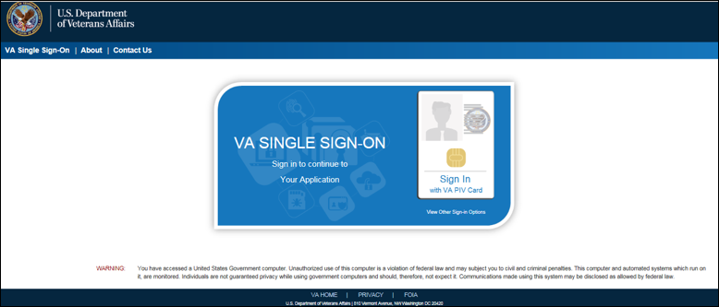

Figure 1.1 – Select Certificate

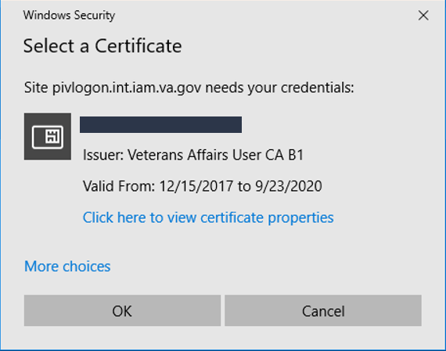

Figure 1.2 – Enter PIN

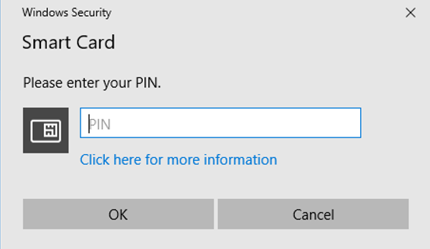

1. Once authenticated by the Single Sign-On system, user is directed to the MCCF EDI TAS Portal. See Section 3.3.1 – MCCF EDI TAS Portal Home Page

## *Future Release* - Logging Out of the Current MCCF EDI TAS Portal Session

To end the current session and exit the MCCF EDI TAS Portal, click the Logout Link in the toolbar next to the eRevenue Resources link

Figure 2 – MCCF EDI TAS Portal Log Out Link



A logout screen will be displayed indicating the user has logged out of eBusiness Solutions.The user will still be able to navigate to another application protected by VA Single Sign-On without logging in.

Figure 2.2 – MCCF EDI TAS Portal – eBusiness Soluton Logout Screen

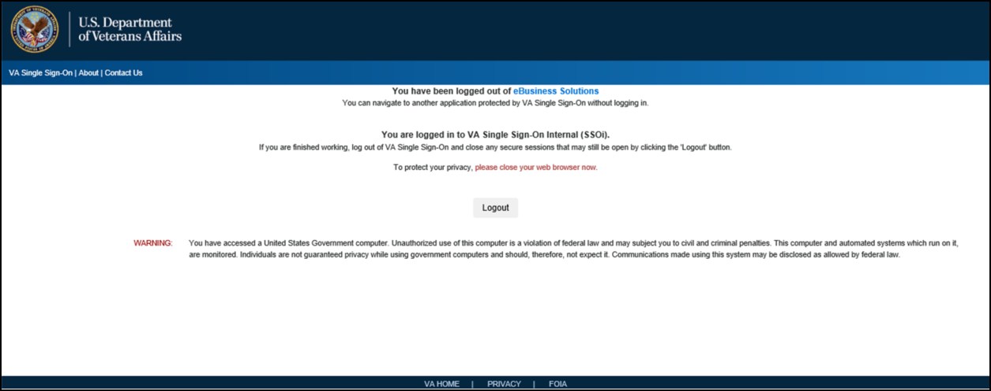

To log out of SSOi, select the Logout button.

Figure 2.3 – MCCF EDI TAS Portal – Logout of SSoi

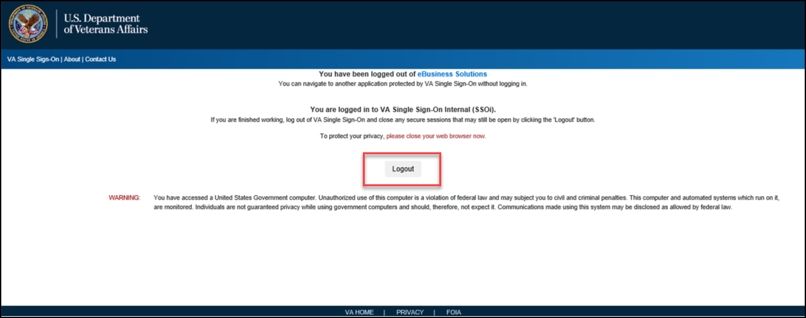

A confirmation screen will be presented to the user that they have been logged out of VA Single Sign-On.

Figure 2.4 – MCCF EDI TAS Portal – Confirmation Screen Logout SSOi Successful

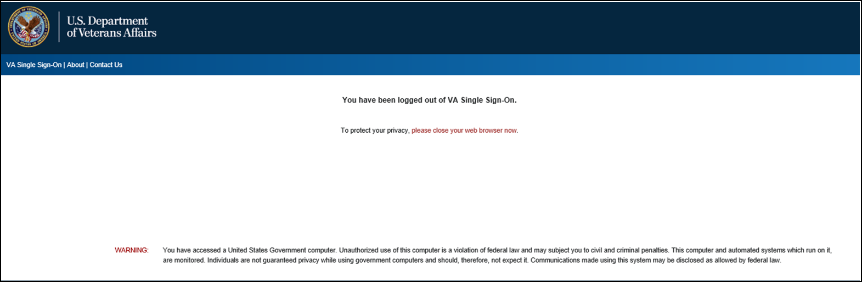

A MCCF EDI TAS Portal session will end automatically after 60 minutes of inactivity. Automatic termination of a session does not clear the last screen in use and display the Login page, but connectivity to, and the functionality of the MCCF EDI TAS Portal is terminated. To re-open a new session of the MCCF EDI TAS Portal, login into the MCCF EDI TAS Portal again.

## Elements and Functionality of the MCCF EDI TAS Portal

### MCCF EDI TAS Portal Home Page

After successful login, users will see the **MCCF EDI TAS Portal Home Page** (Figure 3). The users’ name is shown in the upper right corner of the application.

**PLEASE NOTE**: The user is not provided with an option to customize the view.

Figure 3 – MCCF EDI TAS Portal Home Page

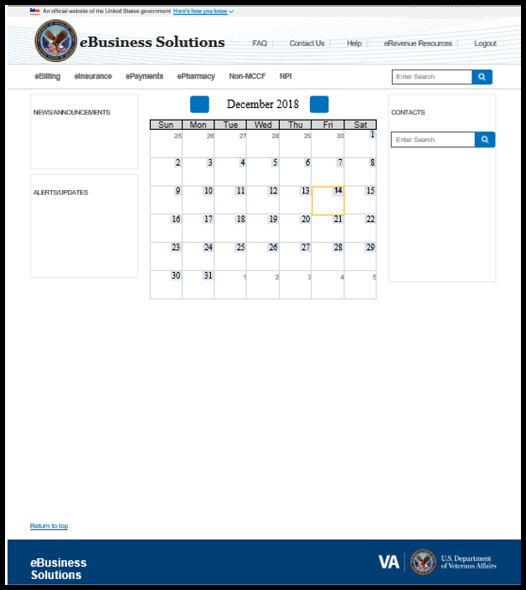

### Portal Menu

Each portal page has a header (highlighted in Figure 4) that enables quick access to the following features:

* Online Help and FAQs
* Contact eBusiness Solutions (Contact Us)
* eRevenue Resources SharePoint Site

Figure 4 – MCCF EDI TAS Portal Header Links



The following functions can be completed from the portal home page and/or Product pages (highlighted in Figures 5– 9):

* Access Product Pages
* Return to the eBusiness Solutions Home Page
* Perform Sitewide Search
* View News/Announcements, and Alerts/Updates
* Search Contacts

Figure 5 – More MCCF EDI TAS Portal Functionality – Access Product Pages



Figure 6 – More MCCF EDI TAS Portal Functionality – Return to eBusiness Solutions Home Page

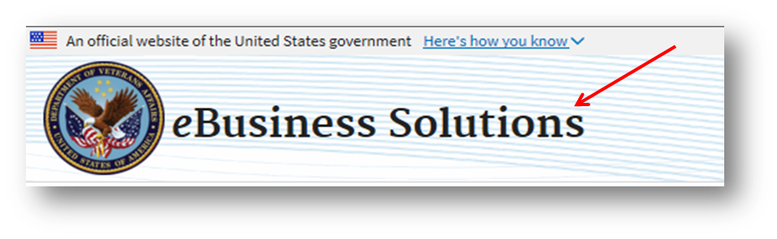

Figure 7 – More MCCF EDI TAS Portal Functionality – Perform Sitewide Search



Figure 8 – More MCCF EDI TAS Portal Functionality – View News/Announcements and Alerts/Updates

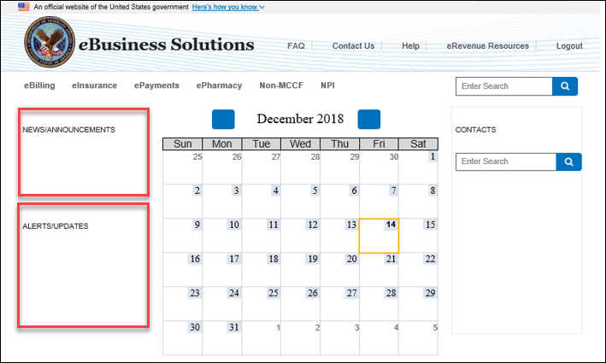

Figure 9 – More MCCF EDI TAS Portal Functionality – Search Contacts

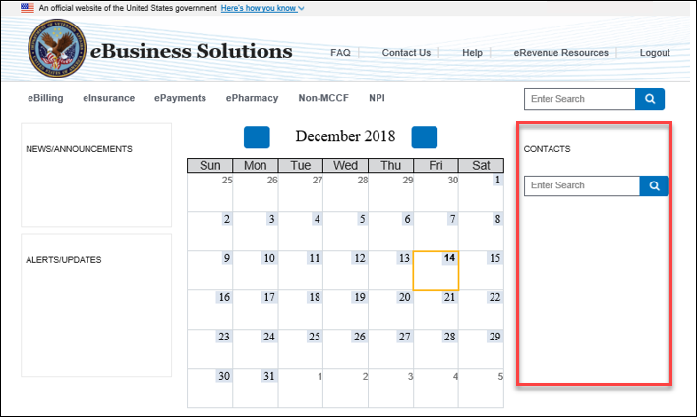

### Accessing Product Pages

The Product Pages are accessible by selecting a Product Page link in the navigation bar section of the GUI. When the Product Page is accessed, the Product Home Page is displayed (Figures 10-16).

1. From the eBusiness Solutions Home Page select any of the Product Page links from the navigation bar.
2. The system will display the Home Page of the selected Product Area.

Figure 10 – eBilling Home Page

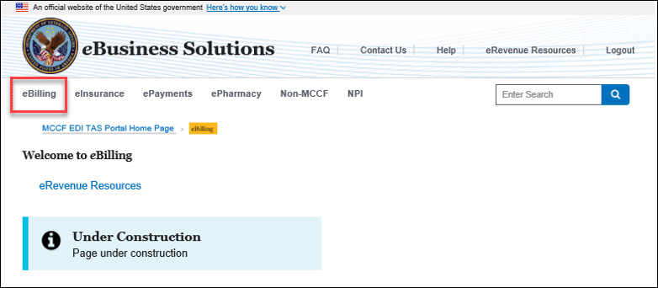

Figure 11 – eInsurance Home Page

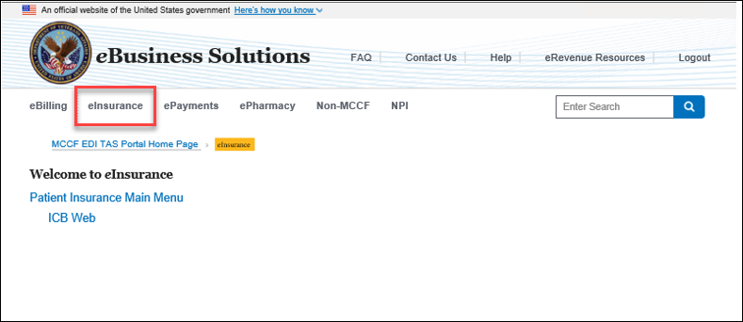

Figure 12 – ePayments Home Page

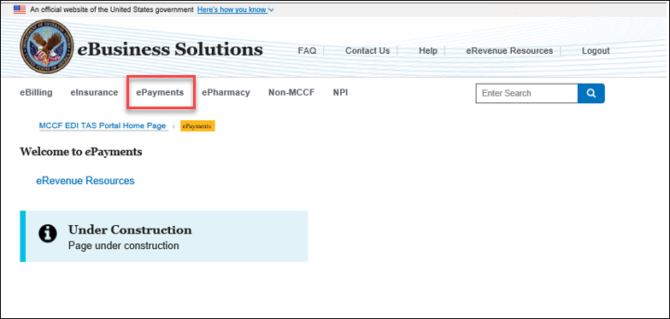

Figure 13 – Pharmacy Home Page

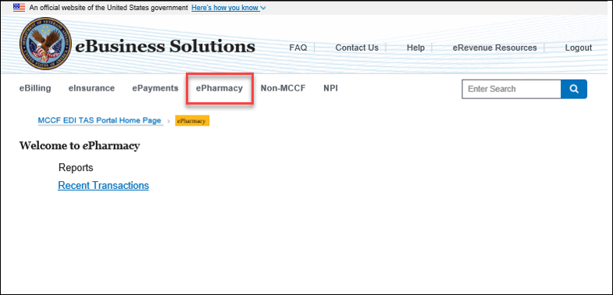

Figure 14 – Non-MCCF Home Page

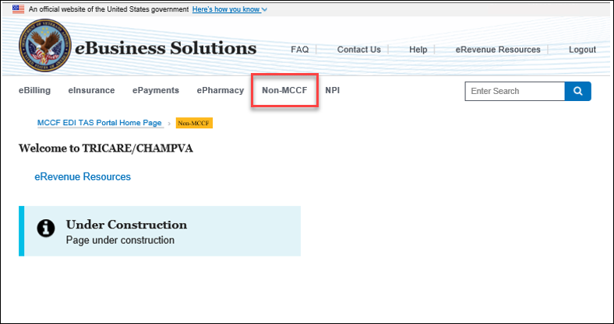

Figure 15 – NPI Home Page

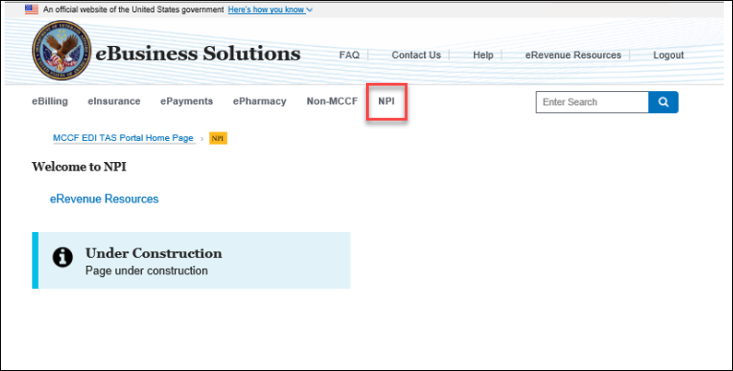

### Sitewide Search

The Sitewide Search feature can be accessed from the Navigation Bar on any page in the MCCF EDI TAS Portal.

Figure 17 – Access Sitewide Search from eBusiness Solutions Home Page

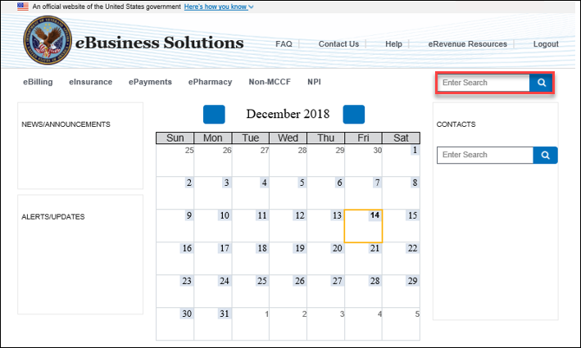

Figure 18 – Access Sitewide Search from All Other Pages

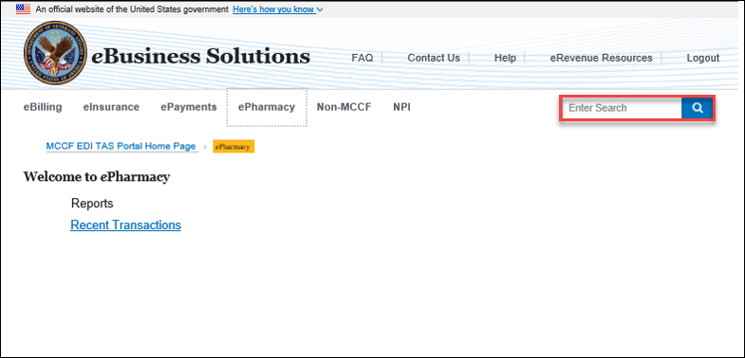

***The content that can be searched has not been defined. This section will be updated as the functionality is completed.***

### Accessing FAQs

The FAQ (Frequently Asked Questions) page can be accessed from the header on any page in the MCCF EDI TAS Portal.

Figure 19 – Access to FAQs

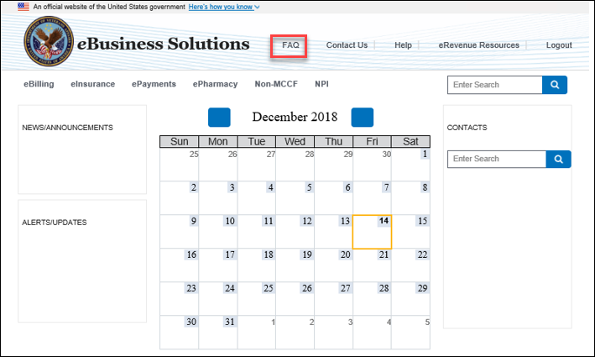

Figure 20 – FAQ Home Page

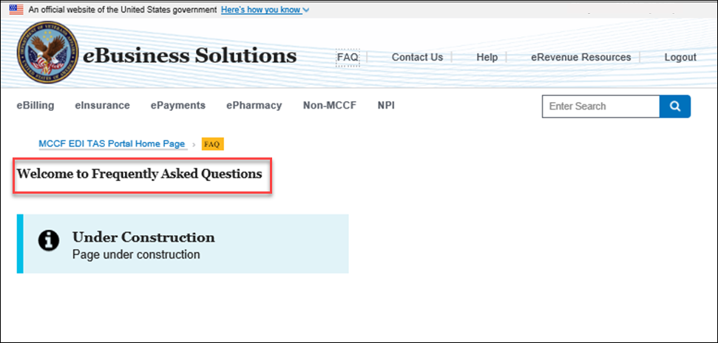

***The FAQ content has not been defined. This section will be updated as the functionality is completed.***

### Accessing Contact Us Page

The Contact Us Page can be accessed from the header on any page in the MCCF EDI TAS Portal. This page provides the user with the following options:

* + Phone Number
  + eMail Address
  + Provide Feedback Link

Figure 21 – Accessing the Contact Us Page

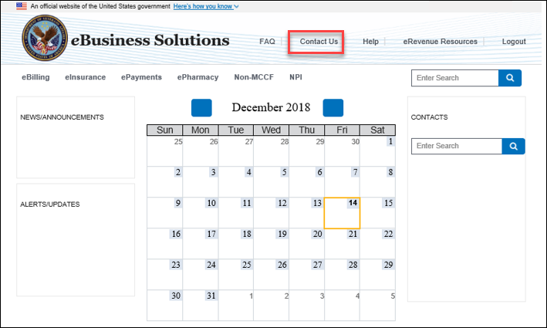

Figure 22 – Contact Us Home Page

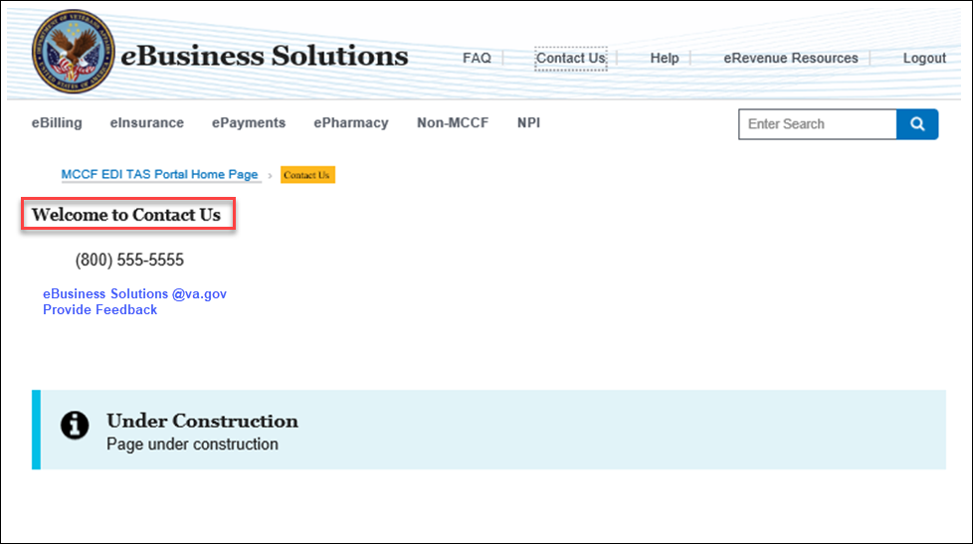

### Accessing Help

The Help page can be accessed from the header on any page in the MCCF EDI TAS Portal.

Figure 21 – Accessing the Help Page

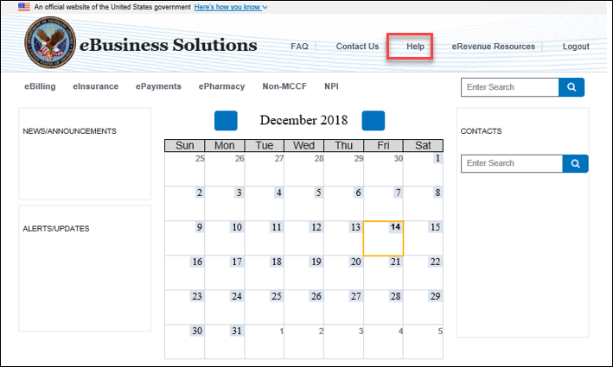

Figure 22 –Help Home Page

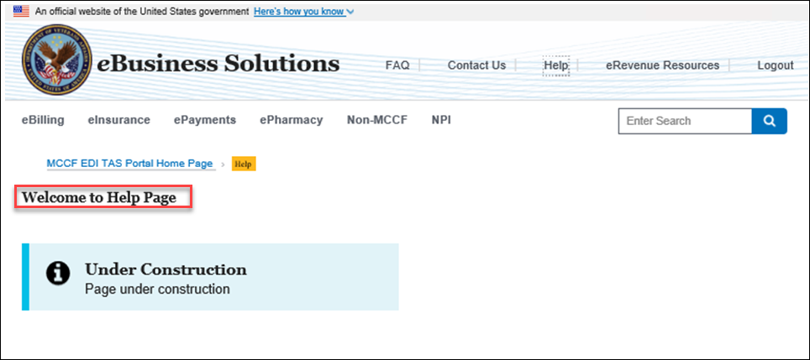

***The Help content has not been defined. This section will be updated as the functionality is completed.***

### Accessing the eRevenue Resources SharePoint Site

The eRevenue Resources SharePoint Site (eRR) can be accessed from the header on any page in the MCCF EDI TAS Portal or from the eRevenue Resources Link on any of the Product Pages.

Figure 23 – Accessing eRevenue Resources Site from the Header

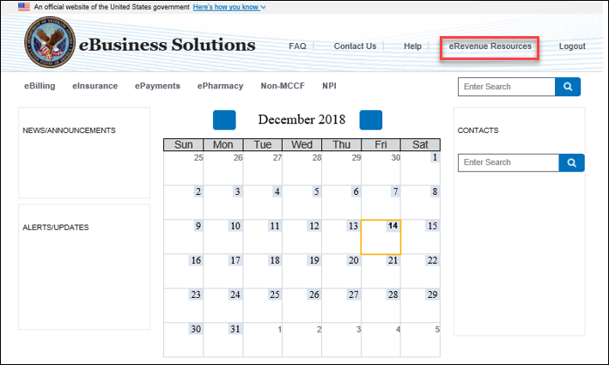

Figure 24 – Accessing eRevenue Resources Site from the Product Pages

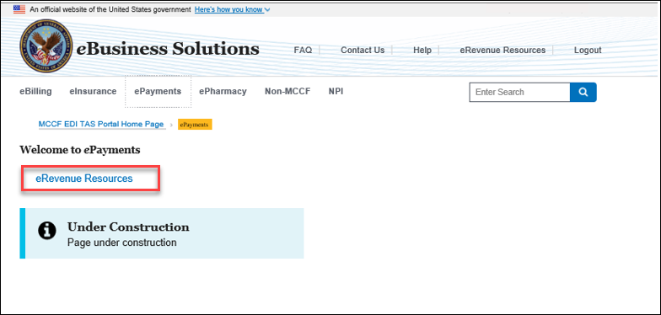

Once the link is selected, the system prompts the user with a Warning message indicating they are being redirected to the eRevenue Resources SharePoint Site.

Figure 24 – Warning Message

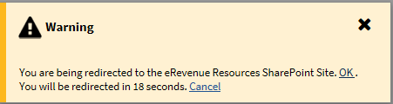

If the user selects ‘OK’, then the user will be taken to the Home Page of the eRevenue Resources site which will be opened in a new tab of the existing browser window. If the user selects ‘Cancel’, the system will close the Alert box and take the user back to the previous page.

Figure 25 – eRevenue Resources SharePoint Site Home Page

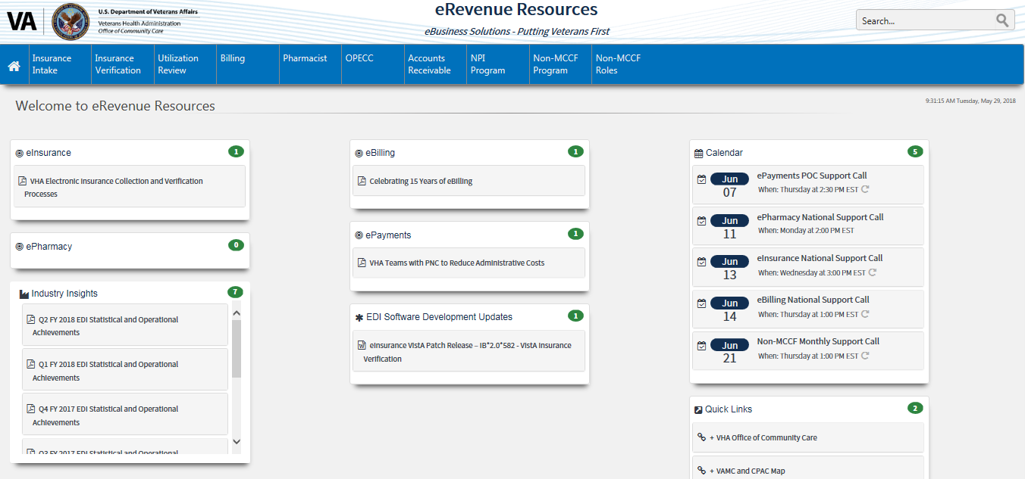

### Accessing the ICBWeb

The user will be able to access the ICBWeb Site from the eInsurance Home Page.

Figure 26 – Accessing ICB Web Site

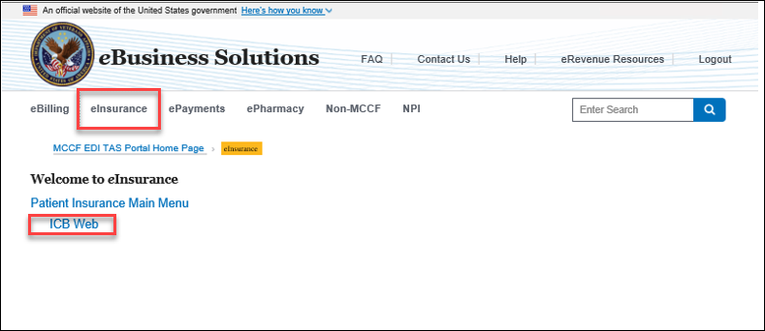

Once the link is selected, the system prompts the user with a Warning message indicating they are being redirected to the ICB Web Site.

Figure 27 – Warning Message

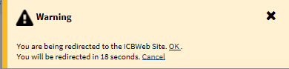

If the user selects ‘OK’, then the user will be taken to the ICB Website which will be opened in a new tab of the existing browser window. If the user selects ‘Cancel’, the system will close the Alert box and take the user back to the previous page.

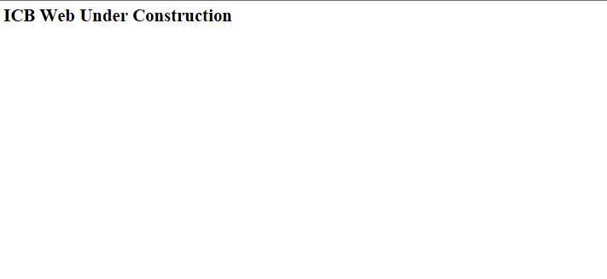

***The ICB Website is still under construction. This section will be updated as the functionality is completed.***

## Caveats and Exceptions

There are no special actions required by the user.

# Using the Software

## Special Instructions for Error Correction

There are no special instructions for the user.

# Acronyms and Abbreviations

The following list of acronyms are those used by the MCCF EDI TAS Portal application and those referenced in this document. For a complete list of Veterans Affairs (VA) acronyms, visit [VA Acronym Lookup](http://vaww1.va.gov/acronyms/index.cfm)

|  |  |
| --- | --- |
| Acronym | Meaning |
| CAG | Citrix Access Gateway |
| EDI | Electronic Data Interchange |
| EO | Enterprise Operations |
| eRR | eRevenue Resources SharePoint Site |
| ESD | Enterprise Service Desk |
| GFE | Government Furnished Equipment |
| GUI | Graphical User Interface |
| ICB | Insurance Capture Buffer |
| ID | Identifier of Identification |
| IT | Information Technology |
| MCCF | Medical Collection Care Fund |
| OI&T | Office of Information and Technology |
| SDD | System Design Document |
| POC | Point of Contact |
| TAS | Transaction Application Suite |
| UI | User Interface |
| URL | Uniform Resource Locator |
| VA | Department of Veterans Affairs |
| VistA | Veterans Health Information Systems and Technology Architecture |

# Appendix